**SCHEDULE 6.4 - SERVICE DESCRIPTION**

**TRANSMISSION MANAGED SERVICESERVICE (TMS)**

1. THE SERVICE

###### Service Description

## The Transmission Managed Service (**TMS**) is a high-speed circuit that uses Dense Wavelength Division Multiplexing (**DWDM**) on the Access Provider’s dedicated fibre within the Kingdom of Bahrain between:

### two Access Seeker’s Core Network site; and

### an Access Seeker’s Point of Presence and a Data Center or Landing Station as the case may be.

## The TMS Service is provided with a bandwidth speed specified in Annex 1 of this Service Description.

## The TMS Service is available to Access Seekers holding an Individual Telecommunications License.

1. DEFINITIONS

Capitalised terms not defined in this Service Description are defined in Schedule 8 - (Dictionary) of the Reference Offer. Terms defined in this Service Description are specific to it.

**Access Seeker Core Site** means a location in the Kingdom of Bahrain owned or controlled by the Access Seeker which hosts equipment for control functionality on its Network.

Landing Station means a location where international cables terminated inside the Kingdom of Bahrain which provide cross connections between international carriers and Licensed Operators in the Kingdom of Bahrain.

A data center means a location where an Access Seeker hosts and/or collocate its Network equipment, but for the avoidance of doubt cannot be at an End User Premises (except if such Strategic Partner location), cable station, earth station, manhole, power room, lead-in pipe, duct, outdoor cabinet, MDF, riser room or anywhere not on the main island of Bahrain. A location will qualify as a data center if it meets the following minimum requirements: (i) a minimum power usage of 20KW and a minimum of 4 telecom racks with Core Network Equipment.

**Connection** means an individual TMS Service.

**Customer Premises Equipment or CPE** means that Equipment forming part of the TMS at the Core Site / Point of Presence/ Landing Station

**Minimum Service Period** means an applicable minimum period of twenty-four (24) calendar months for which the TMS Service shall be provided, such period commencing from the Service Commencement Date.

**TMS Amended Service** means an TMS Service that is amended by a Change Request.

**TMS Service** means the service defined at paragraph 1 above.

**TMS Operations Manual** means Annex 4 of this Schedule 6.4,

**Renewed Minimum Service Period** means an applicable minimum period of one (1) month for which the TMS Service shall be provided, such period commencing from the expiry of a Service Period.

**Service Period** means the Minimum Service Period or Renewed Minimum Service Period.

1. TERMS

###### Use of Service

## The TMS Service shall only be made available to connect an Access Seeker’s Points of Presence or Core Network site and Data Center or Landing Station or another Point of Presence and not any other residential or non-residential entity or End User. The Access Seeker may not resell the TMS Service to another Licensed Operator.

## Where the Access Provider reasonably suspects breach of paragraph 3.6, it may refer the matter as a complaint for investigation by the Authority.

## Where the Authority establishes after an investigation under paragraph 3.7 that an Access Seeker is not using the TMS Service in accordance with this Service Description, the Access Provider without prejudice to any other rights and remedies under the Supply Terms may by immediate written notice suspend or terminate the specific TMS Connection and the Access Seeker shall be liable to pay the Access Provider liquidated damages calculated in accordance with paragraph 3.22.

###### Supply of Service

## The Access Seeker shall submit a Service Request to the Access Provider to request supply of the TMS Service in accordance with the process set out in the TMS Operations Manual.

## 

## Subject to the Access Seeker fulfilling all of its obligations set out in paragraphs 3.27 to 3.32 below, the Access Provider shall provide and the Access Seeker shall acquire the TMS Service either within the standard timescales or by the Exceptional Delivery Date as appropriate.

## The Service Level Terms shall apply to:

### New Connection – provide a new TMS Service as requested by the Access Seeker;

### Upgrade or Downgrade;

### Hot and Cold Migration – changing the End User address of an existing Connection, requiring disconnection and reconnection of the Connection end point, including “hot migration” which is when the Connection is not disrupted and “cold migration” which is when the Connection can be disrupted;

### Reconfiguration – reconfigure technical parameters of an existing Connection; or

### Cancellation – the Access Seeker requests the cessation of an existing Connection.

## Further information relating to the applicable Service Level Terms and Service Level Penalties for the above is detailed in the Schedule 7 – (Service Levels) of the Reference Offer.

###### Amendment to the TMS Service

## The Access Seeker and Access Provider shall comply with the specific process set out for the Amendment to the Transmission Managed Service in the TMS Operations Manual. This shall cover scenarios whereby the Access Seeker requests an internal shift, Relocation, or an external shift. These processes shall be applicable to existing TMS Services only.

###### Access Seeker Obligations

## The Access Seeker shall provide the Access Provider with suitable space for, and access during Working Hours to, any Access Provider Equipment required to be located in any building in which the TMS Service is located within the control of the Access Seeker. If consent is required from a third party, the Access Seeker shall procure such consent. The Access Provider is not required to pay the Access Seeker for the preparation or use of, or access to, space provided pursuant to this sub-paragraph.

## When provisioning a Service Request requiring new Duct build, the Access Provider is responsible for construction of the Duct on public land up until the demarcation point being the boundary of the plot where the Wireless Radio Site is located. The Access Seeker is responsible for construction of the lead-in Duct or in-building Duct or conduit from the demarcation point to the Wireless Radio Site and/or aggregation Point of Presence.

## If the Access Provider’s Equipment requires electricity supply and electricity connection points, they shall be supplied, in the location specified by the Access Provider, to the Access Seeker at the Access Seeker’s expense according to the equipment specification. Such electricity shall be available at the same level of supply, protection and continuity as that available to the Access Seeker’s Equipment, as appropriate.

## The Access Seeker shall be solely responsible for any loss, theft or destruction of, or damage (reasonable wear and tear excepted) to the Access Provider’s Equipment required to be located in the building where the TMS Service is provided and which is within the control of the Access Seeker, occurring any time and howsoever caused (unless caused by the Access Provider or its agents).

## The Access Seeker shall provide the Access Provider and any authorised employee, agent, affiliate or contractor of the Access Provider with all information and assistance that person may reasonably require to design, test, commission and maintain the TMS Service (which may include participation in testing procedures as and when reasonably requested by the Access Provider).

## The Access Seeker may require their agent to be present during the installation, testing or commissioning done by the Access Provider but not so as to affect the Service Commencement Date.

###### Maintenance and Support

## The Access Provider shall provide maintenance and support services in respect of the TMS Service in accordance with the Schedule 7 – (Service Levels) of the Reference Offer.

###### Protection

## TMS Two levels of protection are available in the TMS connections, i.e a) Silver Protection Level and b) Gold Protection Level as delineated in Annex 2 of this Schedule 6.4 and for the additional charges of any of the requested protection level is defined in the Schedule 3. For the avoidance of doubt, availability of the protection shall mean that the feasibility will be required to provision the requested protection level and also the Access Seeker has obtained the premises approval from the landlord and any relevant government authority approvals.

1. CHARGES

## The Access Seeker shall pay to the Access Provider the relevant Charges determined in accordance with Schedule 3 – (Pricing) of the Reference Offer.

## All Charges and sums due from one party to the other under this Agreement are exclusive of VAT. Any VAT shall be charged in accordance with the relevant regulation in force at the time of making the taxable supply and shall be paid by the paying party following receipt from the billing party of a valid VAT invoice.

1. SERVICE LEVELS

## The Access Provider shall provide the TMS Service in accordance with the Service Levels specified in Schedule 7 – (Service Levels) of the Reference Offer.

# ANNEX 1

# CIRCUIT SPEEDS, DEFINED INTERFACES, MEDIA AND TOPOLOGY

|  |  |  |  |  |
| --- | --- | --- | --- | --- |
| **Service element** | **Interface** | **Connector** | **Topology** | **Access** |
| Connection terminating at Core Network Site/Data Center/Landing Station or Point of Presence | OTU2/10G, 25G, OTU3/40G, 50G and OTU4/100G | SFP/XFP, LC/PC | Point-to-point | Fibre |

The TMS Service is provided in accordance with the ITU-T recommendation G.709

# Annex 2

# Provisioning Validation Test

|  |  |
| --- | --- |
| **-** | |
| **-** |  |
|  | - |

|  |  |
| --- | --- |
| **Provisioning Validation Test** | |
| **Testing Methodology** | ITU-T G.709/ ITU-T Y.1564 |
| **Testing Mode** | Testers simulates at both sides of Client card with setting of OTU2/ OTU3/ OUT4 levels and also tester simulates CPE. |
| **Parameters tested** | Frame loss, BERT, Throughput |
| **Tester Setting** | TMS Bandwidth Variants |
| **Test Results** | Copy provided to the Access Seeker upon request at time of testing |

**ANNEX 3**

**TMS SERVICE DIAGRAMS**

The diagrams below are simple representation of a BNET Network used to deliver the TMS Service.

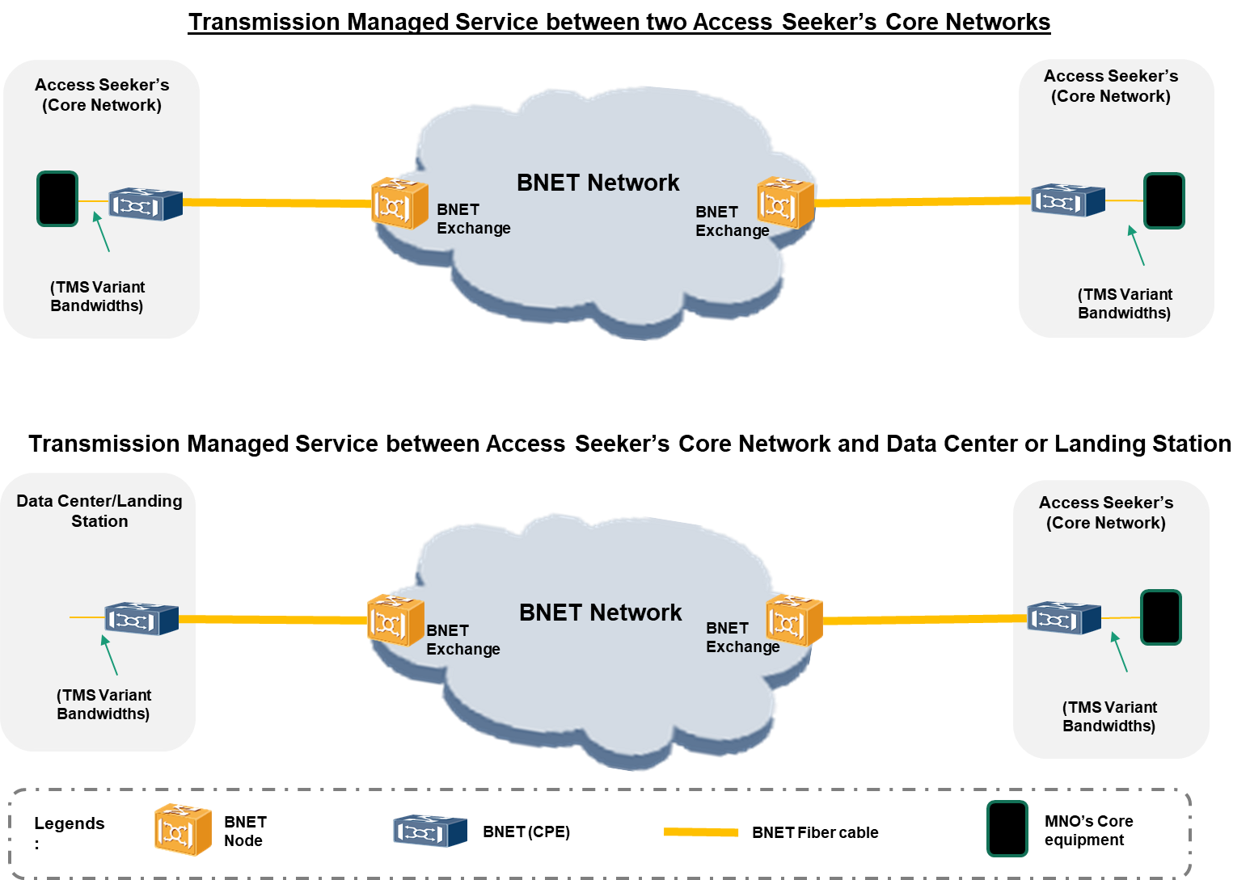

**Optional Levels of Protection available for the TMS Service:**

The Access Provider provides below a summary of the various levels of protection available (based on the feasibility) for the TMS service:

**1. Silver protection**

This protection type, provides the redundant TMS service level at Access connection or Point of Presence connection over the same access fiber cable but two separate fiber pairs between BNET exchange to Data Center or Landing Station or Point of Presence/Core Network with the following specifications of connectivity:

1.1 Same Access CPE

1.2 Same Access BNET Exchange

1.3 Same Access BNET Node

1.4 Same Client card at Access BNET Node with two interfaces

**2. Gold protection**

This protection type, provides the redundant TMS service level at Access connection or Point of Presence connection over the two separate access fiber cable between BNET exchange to Data Cebter or Landing Station or Point of Presence /Core network with the following specifications of connectivity:

2.1 Same Access CPE

2.2 Same Access BNET Exchange

2.3 Same Access BNET Node

2.4 Separate Client cards at Access BNET Node with two separate interfaces

**\*Access Seeker may request any of the above protection level at Landing Station/Data Center or Core Network locations and both protections are considered as separate requests.**

